Project Report Format

1. INTRODUCTION

1.1 Project Overview

This project, titled "Visualizing Housing Market Trends: An Analysis of Sale Prices and Features using Tableau", aims to uncover valuable insights from housing data. Using visual analytics, it explores key factors influencing house prices and sales trends for ABC Company.

1.2 Purpose

The purpose of this project is to enable ABC Company to make data-driven decisions by analysing trends in the housing market. Visualizations created in Tableau provide clarity on how features like renovation, age, bathrooms, bedrooms, and floor count affect housing prices.

1. IDEATION PHASE

2.1 Problem Statement

Real estate stakeholders face challenges in interpreting large volumes of housing data. The project addresses this by visualizing patterns and trends in house pricing and features to support strategic decision-making.

2.2 Empathy Map Canvas



2.3 Brainstorming

* What affects house prices the most?
* Does renovation increase sale value?
* How do features like bathrooms, bedrooms, and floors relate to house age?
* What insights do real estate analysts need?

1. REQUIREMENT ANALYSIS

3.1 Customer Journey Map

A buyer or analyst reviews housing trends, uses Tableau dashboards to understand patterns, and makes pricing or investment decisions.

3.2 Solution Requirement

* Dataset with housing features and sales info
* Tableau Desktop for data visualization
* Dashboard scenarios for clear insights

3.3 Data Flow Diagram

1. Data Ingestion (CSV) →
2. Data Cleaning/Transformation →
3. Tableau Dashboard Creation →
4. Insights for Stakeholders

3.4 Technology Stack

* Tool: Tableau Desktop
* Data Source: CSV/Excel dataset
* Platform: Windows
* Languages: None required (Tableau is low-code)

1. PROJECT DESIGN

4.1 Problem-Solution Fit

To solve the difficulty in understanding market trends, we built Tableau dashboards that simplify and clarify relationships in housing data.

4.2 Proposed Solution

Create multiple visual dashboards representing:

1. Overall data summary
2. Total sales vs. years since renovation
3. House age and renovation status
4. Age distribution by features (bathrooms, bedrooms, floors)

4.3 Solution Architecture

Dataset → Data Prep in Tableau → Visualizations → Interactive Dashboards for Analysis

5. PROJECT PLANNING & SCHEDULING

5.1 Project Planning

| Phase | Description | Timeline |
| --- | --- | --- |
| Phase 1 | Data Collection & Cleaning | Week 1 |
| Phase 2 | Dashboard Development | Week 2-3 |
| Phase 3 | Testing & Feedback | Week 4 |
| Phase 4 | Final Report & Submission | Week 5 |

6.FUNCTIONAL AND PERFORMANCE TESTING

6.1 Performance Testing

Tested dashboard responsiveness with different filters and views. Load time was minimal with optimized extracts in Tableau.

7. RESULTS

7.1 Output Screenshots

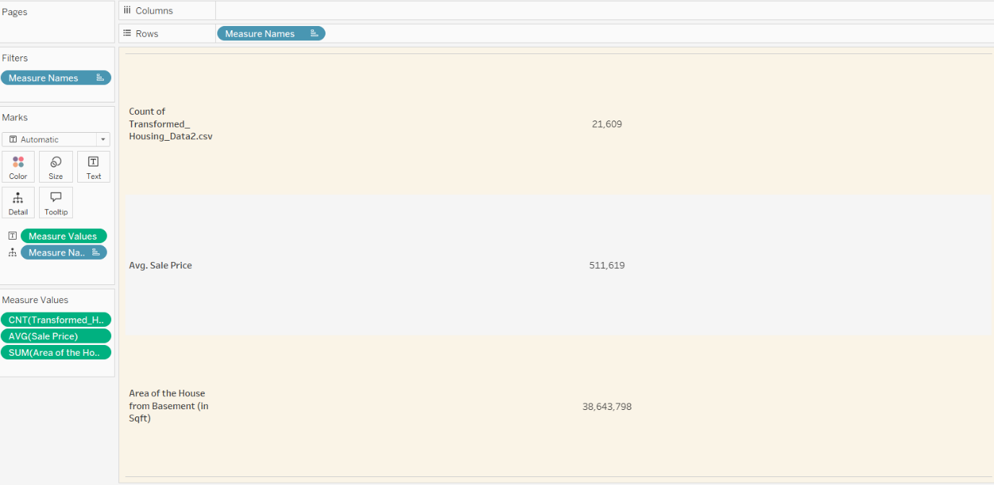

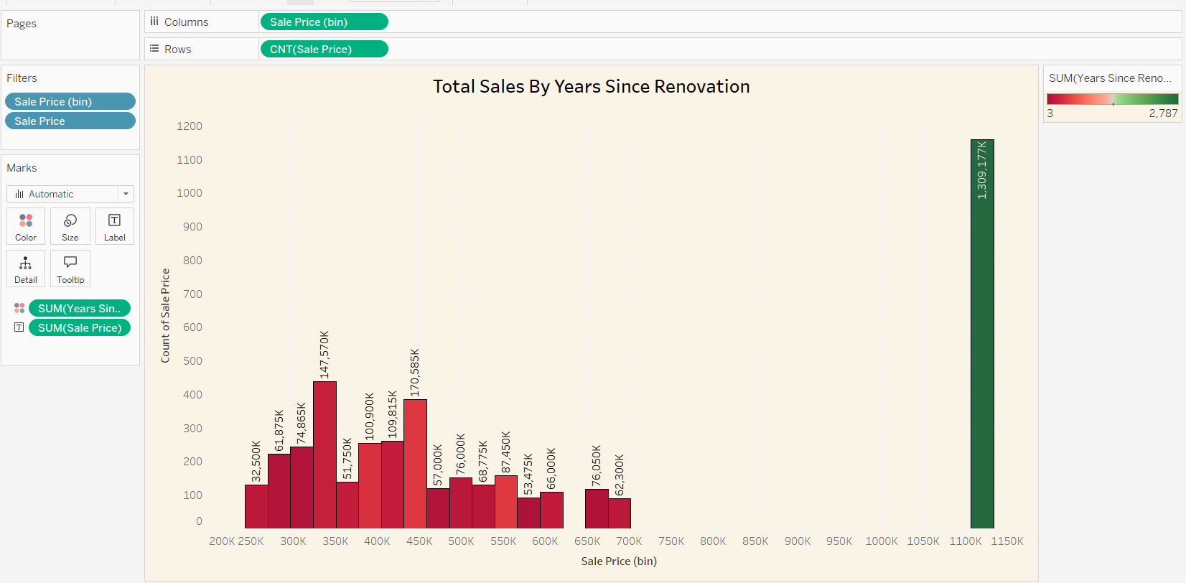

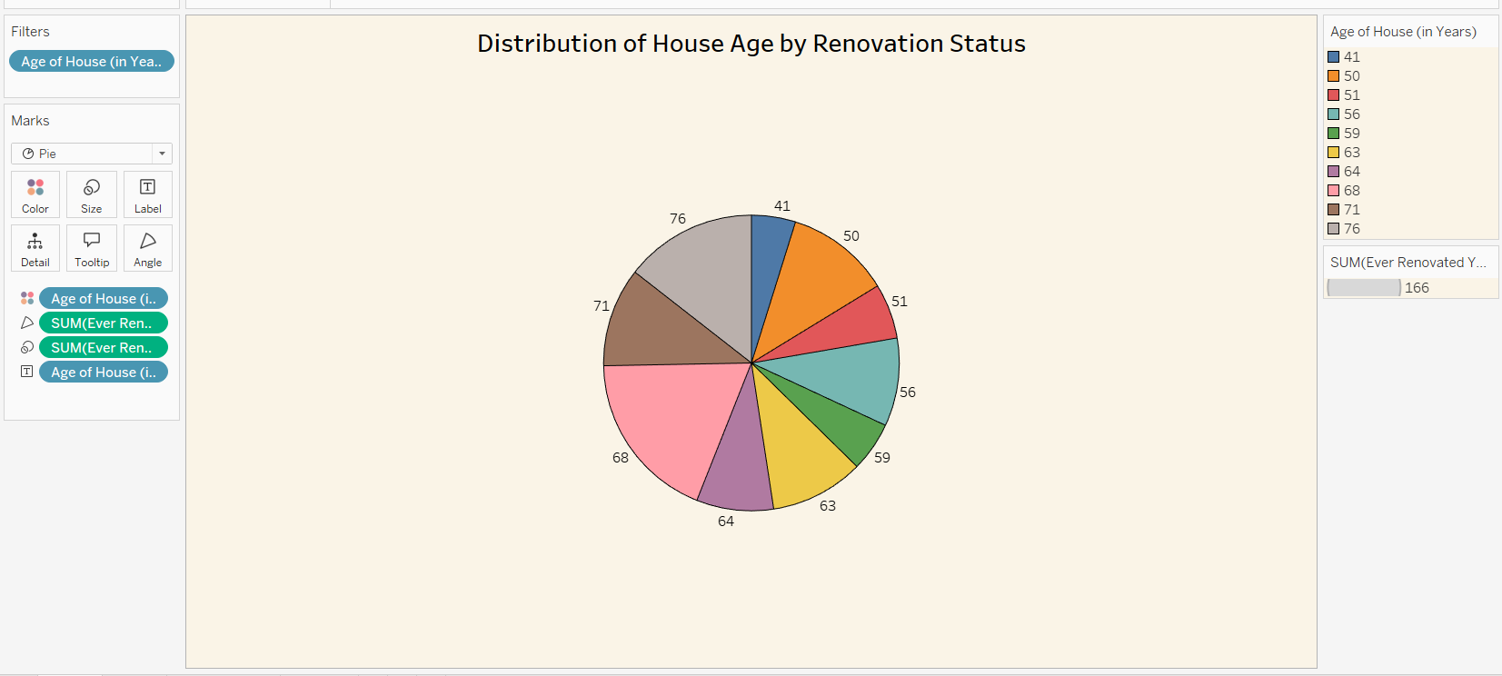

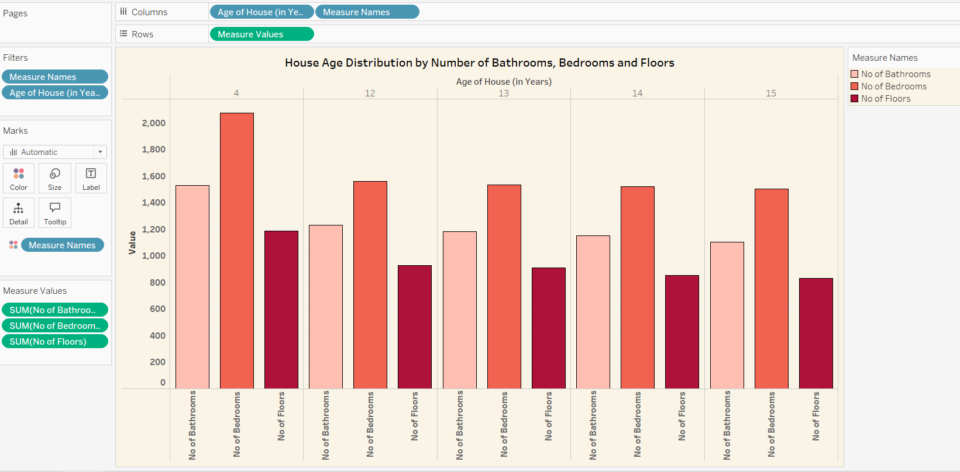

8. ADVANTAGES & DISADVANTAGES

Advantages:

* Easy-to-understand visual dashboards
* Enables informed decisions
* Requires no programming skills

Disadvantages:

* Limited customization in Tableau Free version
* Data must be cleaned before import

9. CONCLUSION

The project succeeded in visualizing complex housing data. ABC Company can now identify key pricing influencers and make data-backed decisions for marketing and investment strategies.

10. FUTURE SCOPE

* Add predictive analytics (e.g., forecast pricing trends)
* Incorporate geospatial visualizations
* Enable real-time data updates

11. APPENDIX

Source Code (if any): N/A  
Dataset Link: https://drive.google.com/file/d/1GkWTTmxOeucXtLP8McuiOJM_Dr8coB0I/view?usp=sharing  
GitHub & Project Demo Link:

https://github.com/NidamanuriBhargav/Visualizing-Housing-Market-Trends-An-Analysis-of-Sale-Prices-and-Features-using-Tableau/tree/main